#### Cardiologic examination report

|  |  |
| --- | --- |
| καρτα2 | **Date: {{ date }}**  **---**  **Mr./Ms. {{ owner }}**  **« {{ petName }} »**  {{ breed }}  {{ sex }}, {{weight }} kg  Age: {{age}} |

**Dr. Theodoros SINANIS**

DVM, MSc, MRCVS

*Master of Science in Veterinary Internal Medicine,*

*Specially trained in Veterinary Cardiology at the*

*Cardiology Unit of Alfort, Paris- France*

*(École Nationale Vétérinaire d'Alfort)*

*European Society of Veterinary Cardiology member*

** Medical history – clinical examination**

**History :**

* Referring physician:**{% if referVet %} {{referVet}}{% else %} -{% endif %}.**
* 2nd cardiologic examination in account of previous degenerative mitral valve disease diagnosis, 3/5 echocardiographic stage, {{clinicalStageRE}} clinical stage (*ACVIM consensus 2019*) {% if hypertensionRE %}, {{hypertensionRE}}{% else %}{% endif %}{% if PGRE %} (PG : {{PGRE}} mmHg){% else %}{% endif %}.
* Last examination: {{preTests}} {% if historic %} {% for moment in historic %}
* {{ moment }}{% endfor %}
* {% endif %}Radiographic examination: {{radiologicalChestAnalysis}}
* Cardiac medication so far:{% if medication %}{% for med in medication %} **{{med.medicationEngMenu}}** ({{med.doseNumber}} {{med.unitOfMeasurementMenu}} {{med.doseMenu}}){% if not loop.last %},{% endif %} {% endfor %}{% else %} **None**{% endif %}**.**

**Clinical findings** :

* {% if rythm %}{{rythm}}{% else %}{% endif %}{% if auditoryFindings %}Cardiac auscultation revealed a {{auditoryFindings.systolicEngMenu}}, {{auditoryFindings.degreeEngMenu}}, {{auditoryFindings.auscultationEngMenu}} murmur, with a PMI at the {{auditoryFindings.auditoryEngMenu}}, {{auditoryFindings.heartEngMenu}} at the {{auditoryFindings.valveEngMenu}}. {% else %}
* Cardiac auscultation revealed a holosystolic, 4th degree (4/6) regurgitant murmur, with a PMI at the left apex of the heart, at the mitral valve area. {% endif %}
* {{auditoryLung}}
* {{cough}}
* {{heartRate}}
* {% if mucous %}{% if mucous**==**’ND.’ %}Mucous membranes: {{mucous}} {% else %}{{mucous}}{% endif %}{% endif %}
* {% if dental %}{% if dental **==**’ND.’ %}Dental calculus: {{dental}}{% else %}{{dental}}{% endif %}{% endif %}
* {{bodyWeight}}.
* {{lymph}}

 **Echocardiography exam results**

The examination was performed with cardiac single crystal phased array probes (P 2-9 & P 1-5 mHz).

{% if PDF %}

|  |  |  |  |
| --- | --- | --- | --- |
| **Parameters** |  | **Parameters** |  |
| RVDd | {% if PDF.RVDd %}{{PDF.RVDd}}{% else %}5.8{% endif %} mm | Ao Vmax | Vmax = {% if PDF.AoVmax %}{{PDF.AoVmax}}{% else %}1.47{% endif %} m/s |
| IVSd | {% if PDF.IVSd %}{{PDF.IVSd}}{% else %}7.6{% endif %} mm | P Vmax | Vmax = {% if PDF.PVmax %}{{PDF.PVmax}}{% else %}0.71{% endif %} m/s |
| LVDd | {% if PDF.LVDd %}{{PDF.LVDd}}{% else %}30.9{% endif %} mm | Ant. mitral leaflet | 3.4 mm |
| PWd | {% if PDF.PWd %}{{PDF.PWd}}{% else %}9{% endif %} mm | Post. mitral leaflet | 2.7 mm |
| IVSs | {% if PDF.IVSs %}{{PDF.IVSs}}{% else %}13.6{% endif %} mm | Mitral E/A wave | {% if PDF.MitralE %}{{PDF.MitralE}}{% else %}1.05{% endif %}/{% if PDF.Awave %}{{PDF.Awave}}{% else %}0.85{% endif %} ({% if PDF.MVEA %}{{PDF.MVEA}}{% else %}1.24{% endif %}) |
| LVDs | {% if PDF.LVDs %}{{PDF.LVDs}}{% else %}15{% endif %} mm | DT | {% if PDF.DT %}{{PDF.DT}}{% else %}38{% endif %} ms |
| PWs | {% if PDF.PWs %}{{PDF.PWs}}{% else %}11.2{% endif %} mm | RA/LA | 0.9 |
| FS | {% if PDF.FS %}{{PDF.FS}}{% else %}51{% endif %} % | Mit. reg. Vmax | {% if PDF.MRVmax %}{{PDF.MRVmax}}{% else %}-{% endif %} m/s |
| LA- Ao | {% if PDF.LA %}{{PDF.LA}}{% else %}29.2{% endif %}-{% if PDF.Ao %}{{PDF.Ao}}{% else %}14.9{% endif %} mm | Tric. reg. Vmax | {% if PDF.TRVmax %}{{PDF.TRVmax}}{% else %}-{% endif %} m/s |
| LA/Ao | {% if PDF.LAAo %}{{PDF.LAAo}}{% else %}2{% endif %} | PT/Ao | 1 |

{% else %}

|  |  |  |  |
| --- | --- | --- | --- |
| **Parameters** |  | **Parameters** |  |
| RVDd | 3.7 mm | Ao Vmax | Vmax = 0.91 m/s |
| IVSd | 8.9 mm | P Vmax | Vmax = 0.68 m/s |
| LVDd | 34 mm | Ant. mitral leaflet | 4.4 mm |
| PWd | 6.3 mm | Post. mitral leaflet | 3.5 mm |
| IVSs | 14.2 mm | Mitral E/A wave | 1.39/1.35 (1.03) |
| LVDs | 10.8 mm | DT | 64 ms |
| PWs | 13.5 mm | RA/LA | 0.9 |
| FS | 68 % | Mit. reg. Vmax | 5.11 m/s |
| LA- Ao | 24.4-14.1 mm | Tric. reg. Vmax | - m/s |
| LA/Ao | 1.8 | PT/Ao | 1 |

{% endif %}

## Interpretation

Περιγραφή: Περιγραφή: ac387 **Right parasternal and transventricular short-axis view (m-mode):**

* Increased end-diastolic & normal end-systolic LV dimensions.
* The contractility of the LV is WNL.
* Normal right ventricular dimensions.

Περιγραφή: Περιγραφή: ac387 **Left atrium examination presents:**

* The left atrial dimensions are increased at the end-systole (LA/Ao = 1.8 >1.6).
* Significant regurgitant volume (~295mm2; 7.9ml) through the mitral valve to the left atrium is present on colour flow Doppler examination.

Περιγραφή: ac387 **Right parasternal and transaortic short-axis view:**

* No anatomic lesions were found at the level of the pulmonary annulus.
* Normal pulmonic flow.
* Mild pulmonic regurgitation is present.

Περιγραφή: ac387 **Right parasternal long-axis four & five chamber views:**

* Mitral valve (anterior leaflet) shows severe thickening and prolapse, compatible with degenerative lessions.
* Normal right atrial dimensions.
* Decreased right to left atrial ratio.
* No aortic regurgitation is present.
* No interventricular nor interatrial septal defect was found.

Περιγραφή: ac387 **Left parasternal long-axis four & five chamber views:**

* Luminar aortic flow at the level of the aortic annulus.
* {% if flow %}{{ flow |e}}{% else %}Increased E transmitral peak flow velocity. {% endif %}
* No tricuspid regurgitation is present on colour-flow Doppler.

Περιγραφή: Περιγραφή: ac387 **Other points:**

* No pericardial nor pleural effusion is present.
* No pulmonary hypertension is present.
* {% if ecg %}{{egc}}{% else %}Sinus rhythm with a few supraventricular premature complexes during the examination. Heart rate: 128-138 bpm. {% endif %}

### Conclusions

* **{{petName}} presents degenerative mitral valve disease** of **3rd** echocardiographic stage (**3/5**); **{{clinicalStage}}** clinical stage (*ACVIM Consensus 2019*), {{hypertension}}{% if PG %} (PG: {{PG}} mmHg){% else %}{% endif %}{% if AddOn %} and {{AddOn}}{% else %}{% endif %}.
* A significant aggravation, because of chordae tendineae rupture and congestive heart faillure, is presented.
* Prognosis remains cautious in this case.
* A 3rd echocardiographic examination is recommended after {% if checkUp %}{% for che, months, years in checkUp %}{{che}} months (**{{months}} {{years}}**) {% endfor %}{% else %}3 months(**July 2022**){% endif %}.

{% if medication2 %}

* Cardiac medication: {% for med2 in medication2 %}

1. **{{med2.medication2EngMenu}}** ({{med2.doseNumber}} {{med2.unitOfMeasurementMenu}} {{med2.doseMenu}}) {% endfor %}{% else%}

* Cardiac medication: **not recommended.**

{% endif %}

**Yours sincerely:**

**Dr. Theodoros Sinanis**

**Δρ. Θεόδωρος Σινάνης**

[theodsin@hotmail.com](mailto:theodsin@hotmail.com)

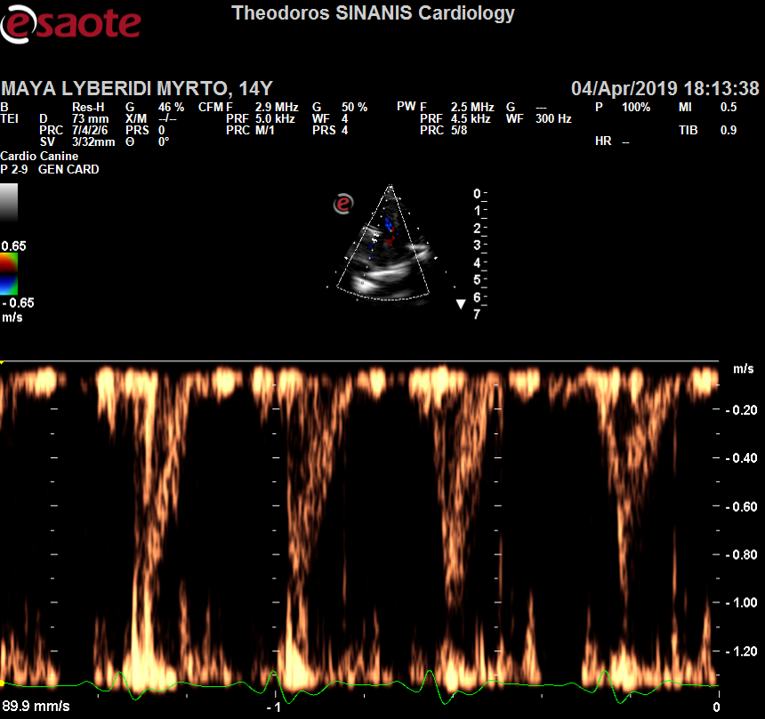 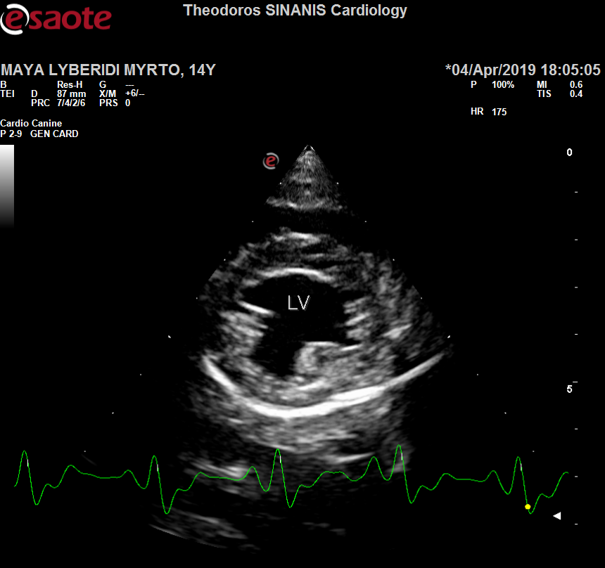

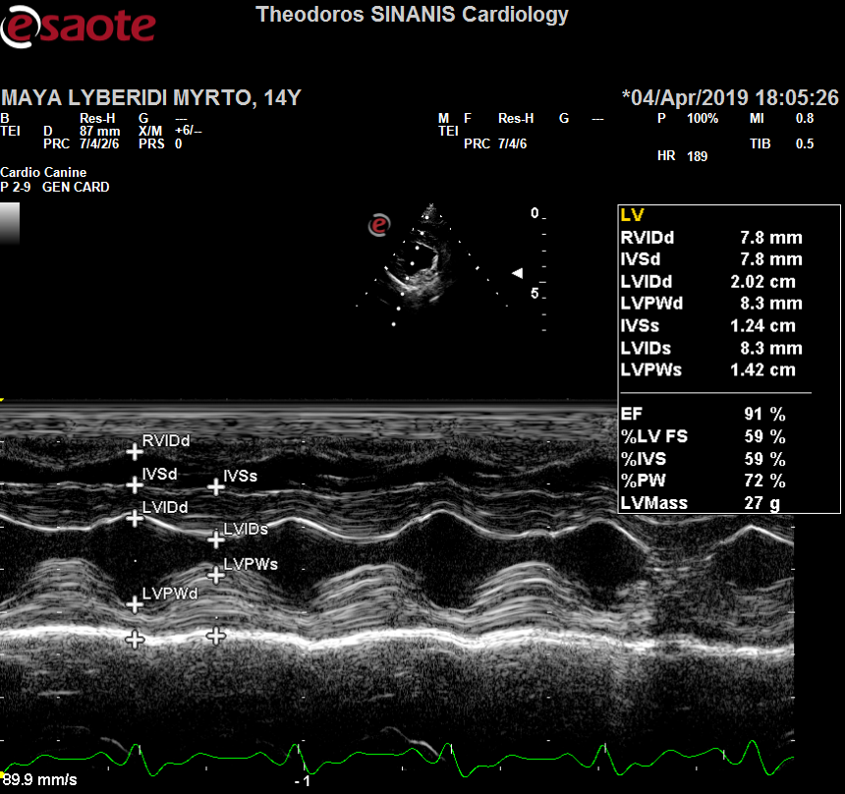 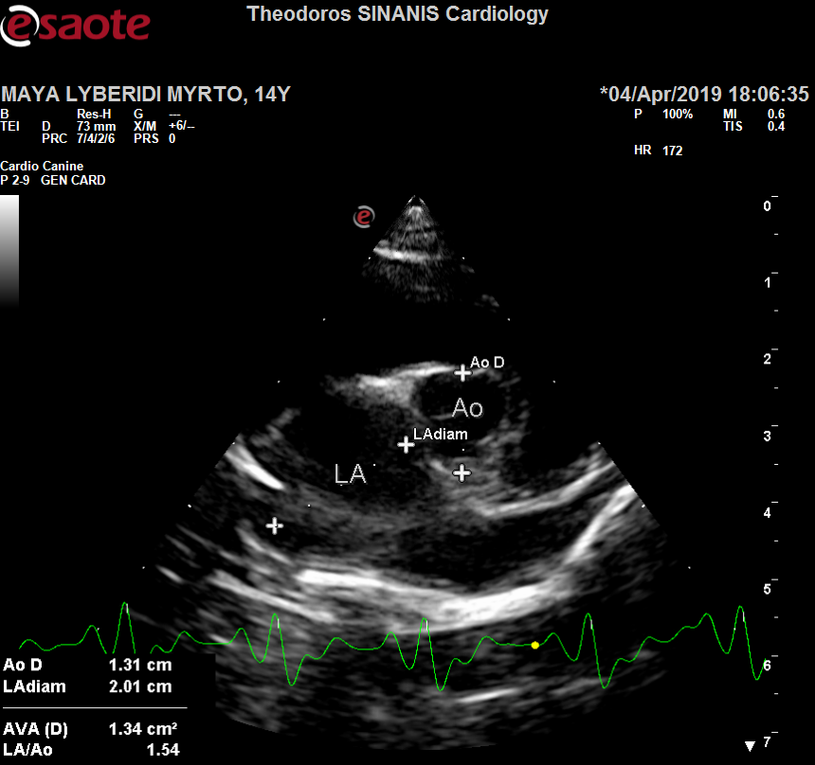

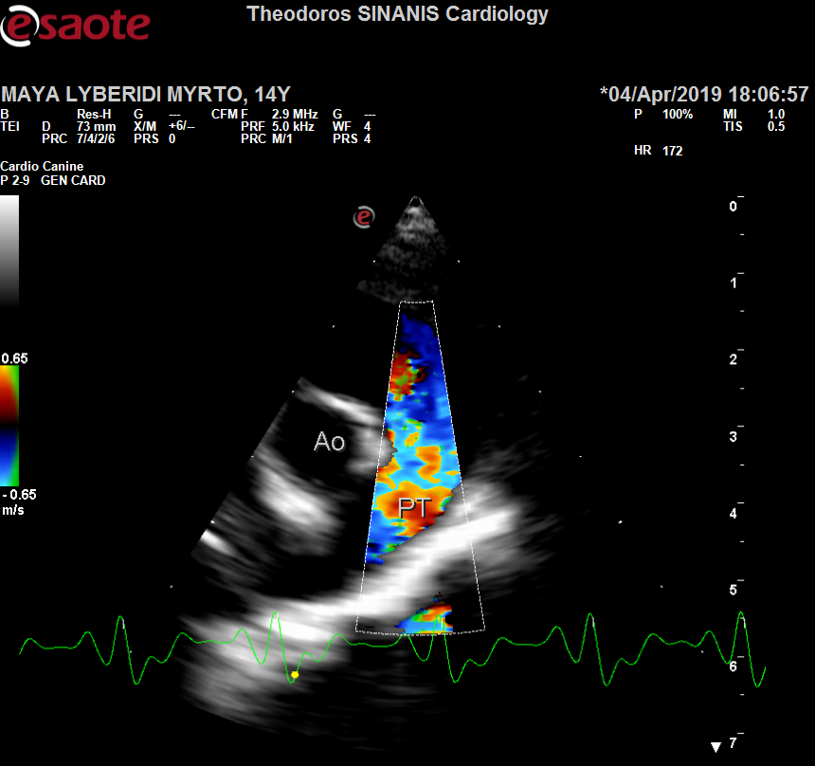 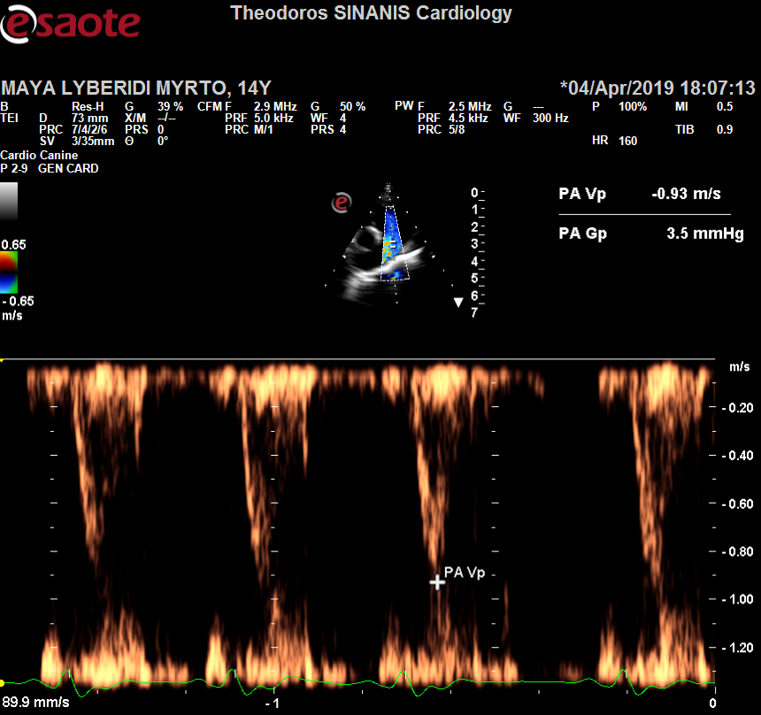

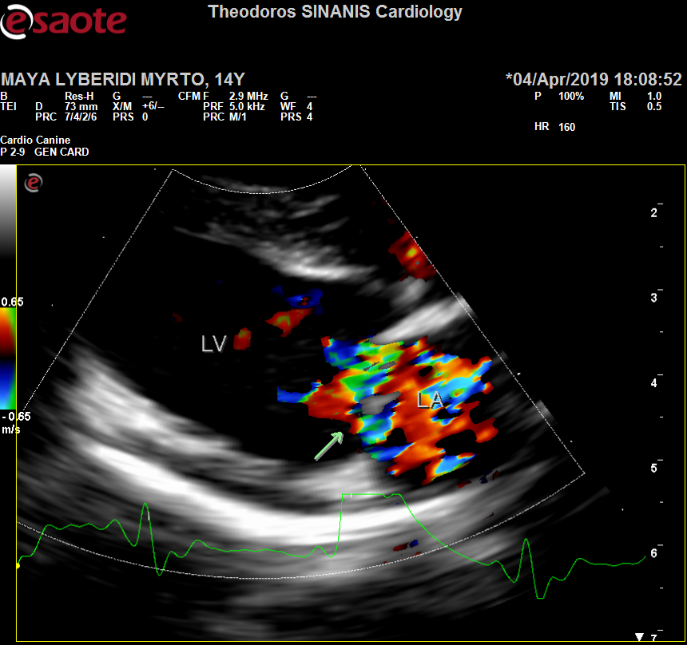 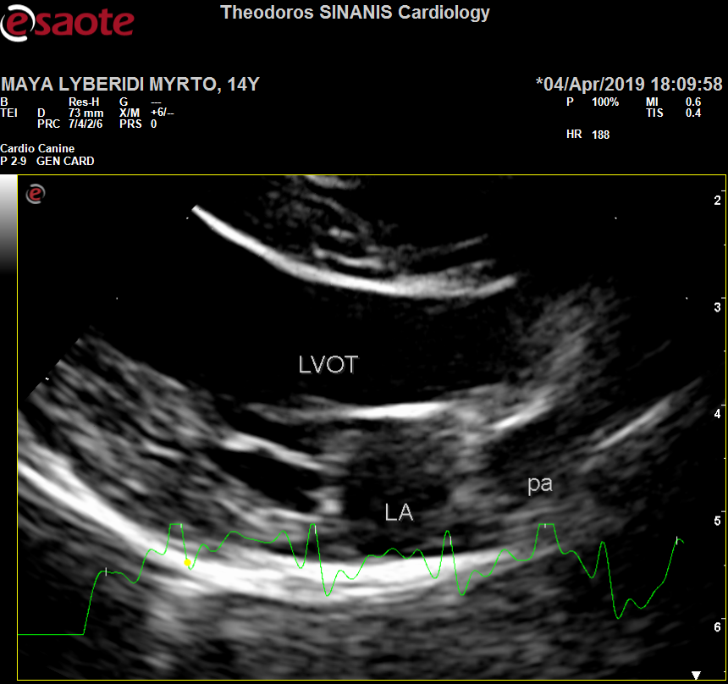

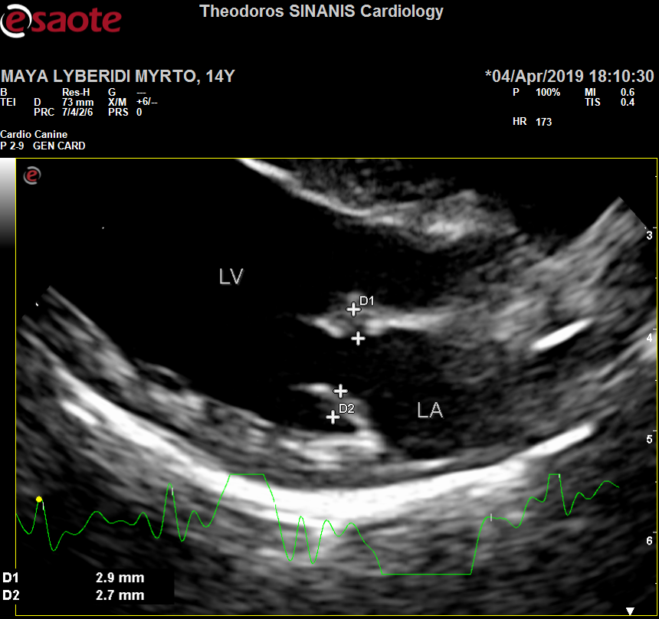 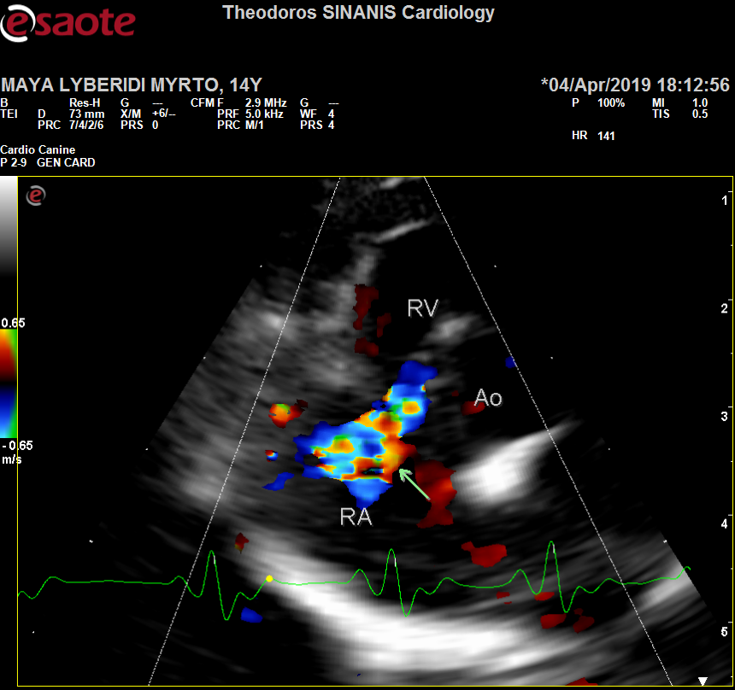

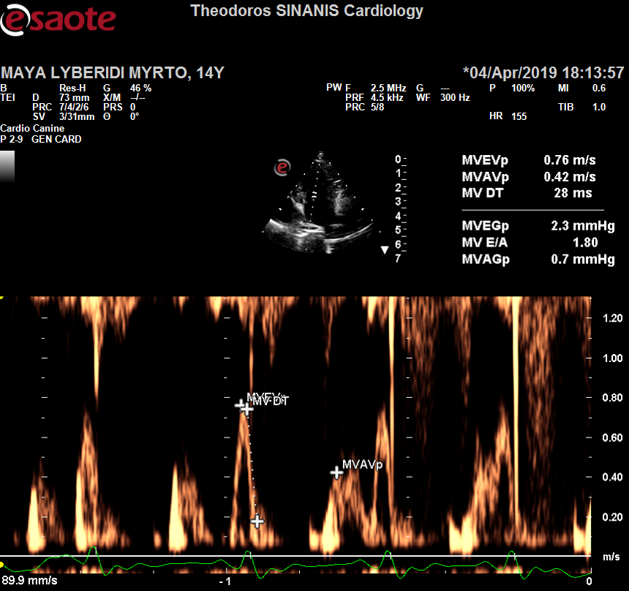 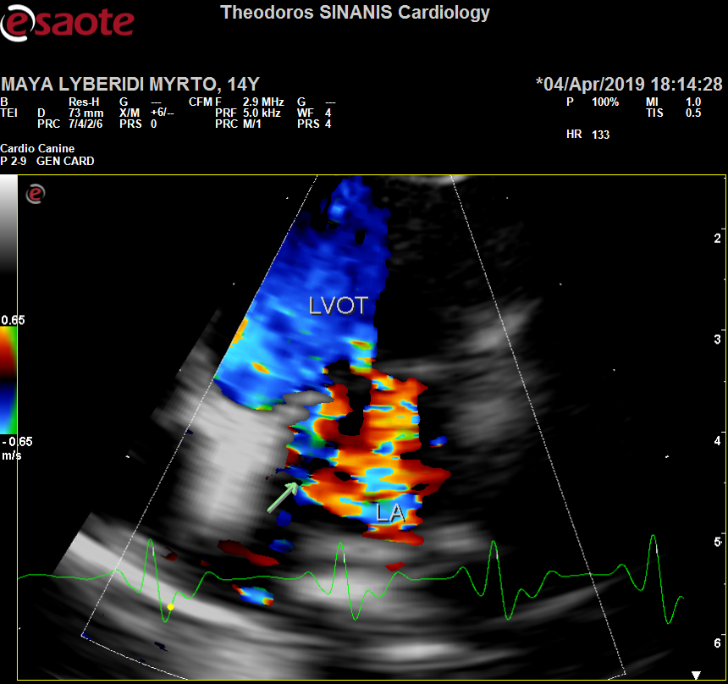Περιγραφή: Περιγραφή: ac387